**Name: SHAMJAD MAZOOD NAZER**

**Roll No: 36**

**Batch: R-MCA B**

**Date: 21/03/2022**

**NETWORKING & SYSTEM ADMINISTRATION LAB**

**Experiment No.: 1**

**Aim**

Install the latest version of Ubuntu on an Oracle VM VirtualBox.

**Procedure**

**Output Screenshot**

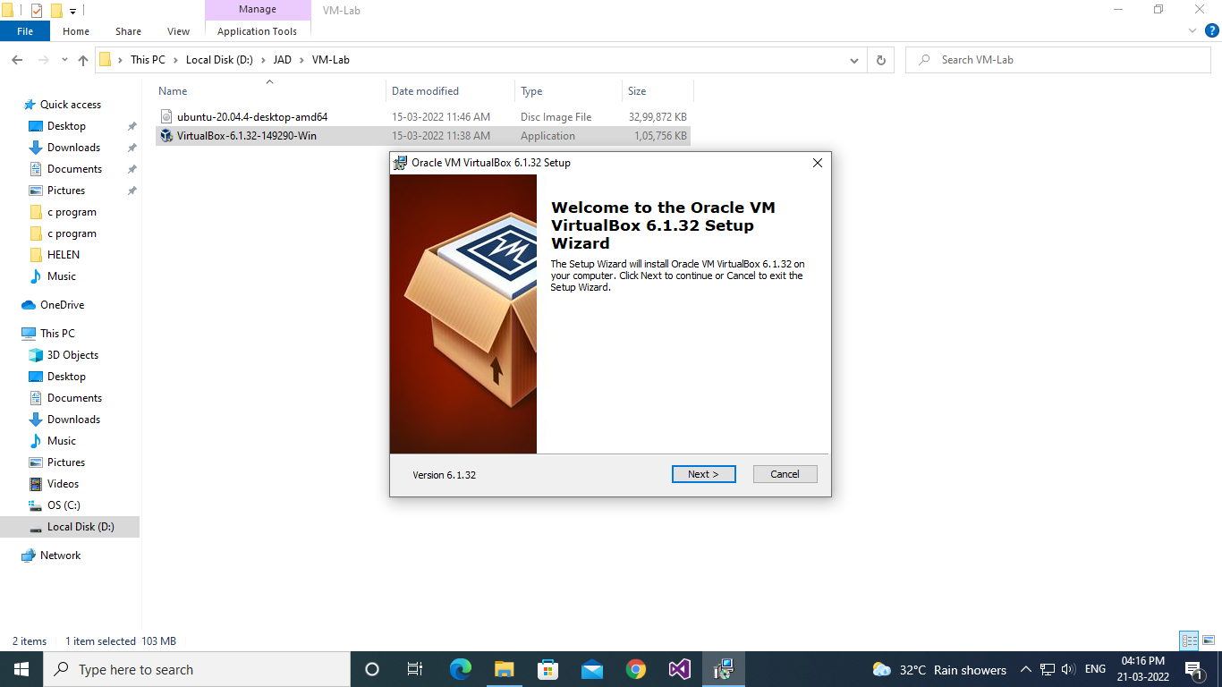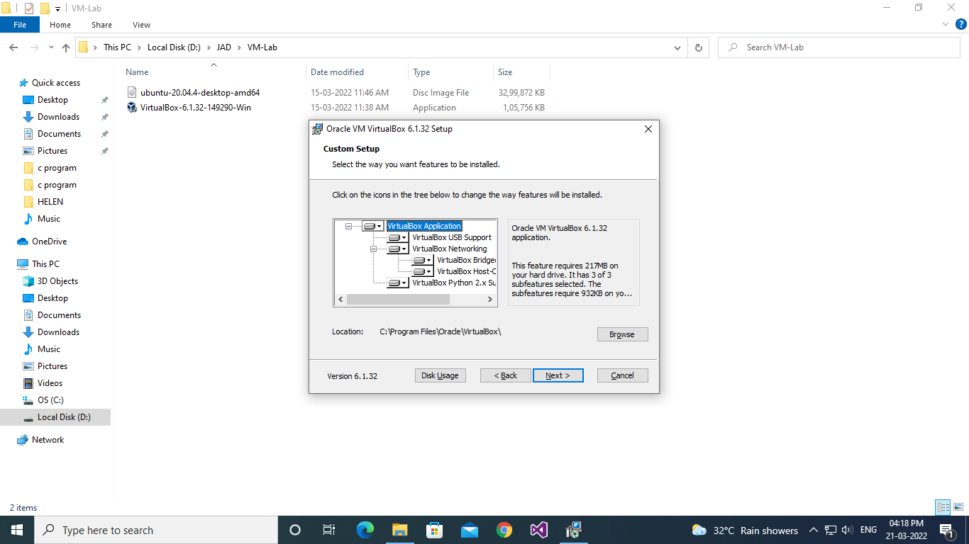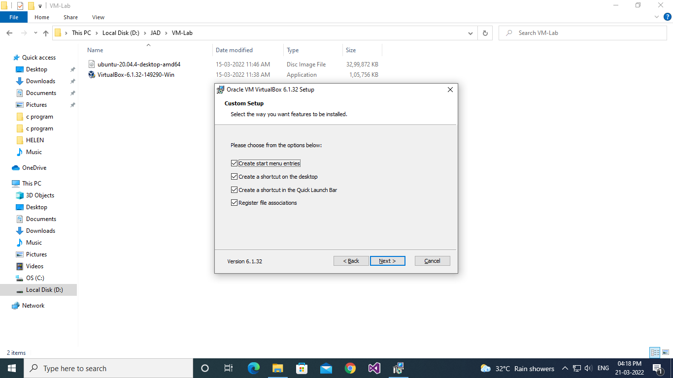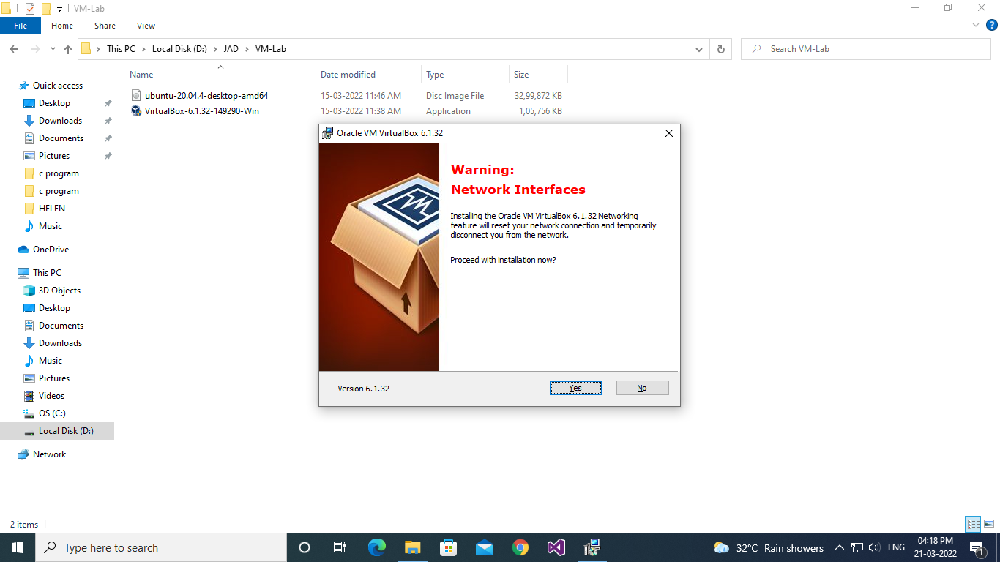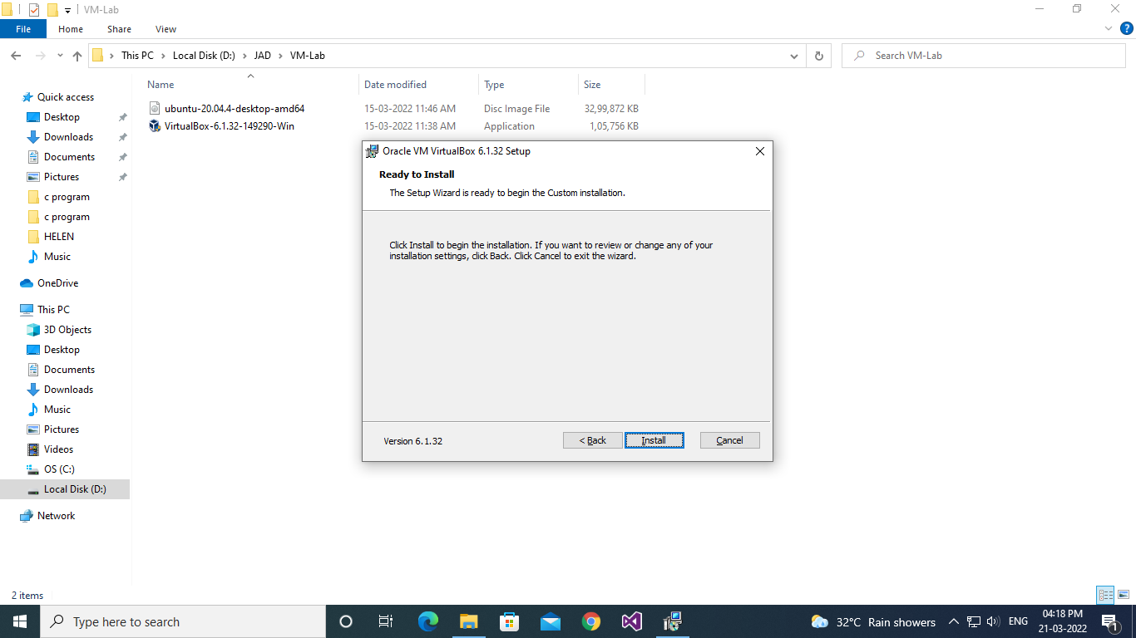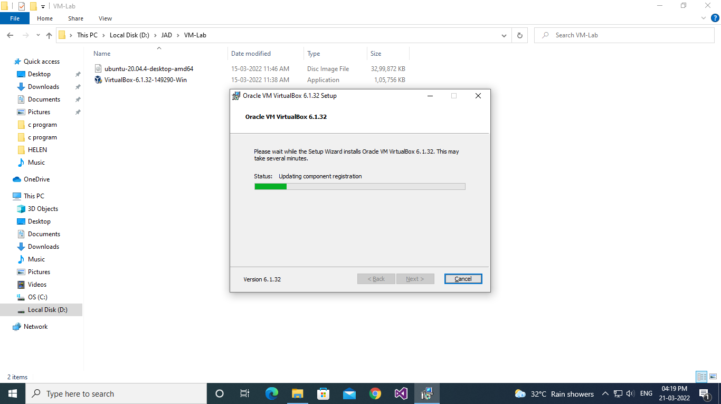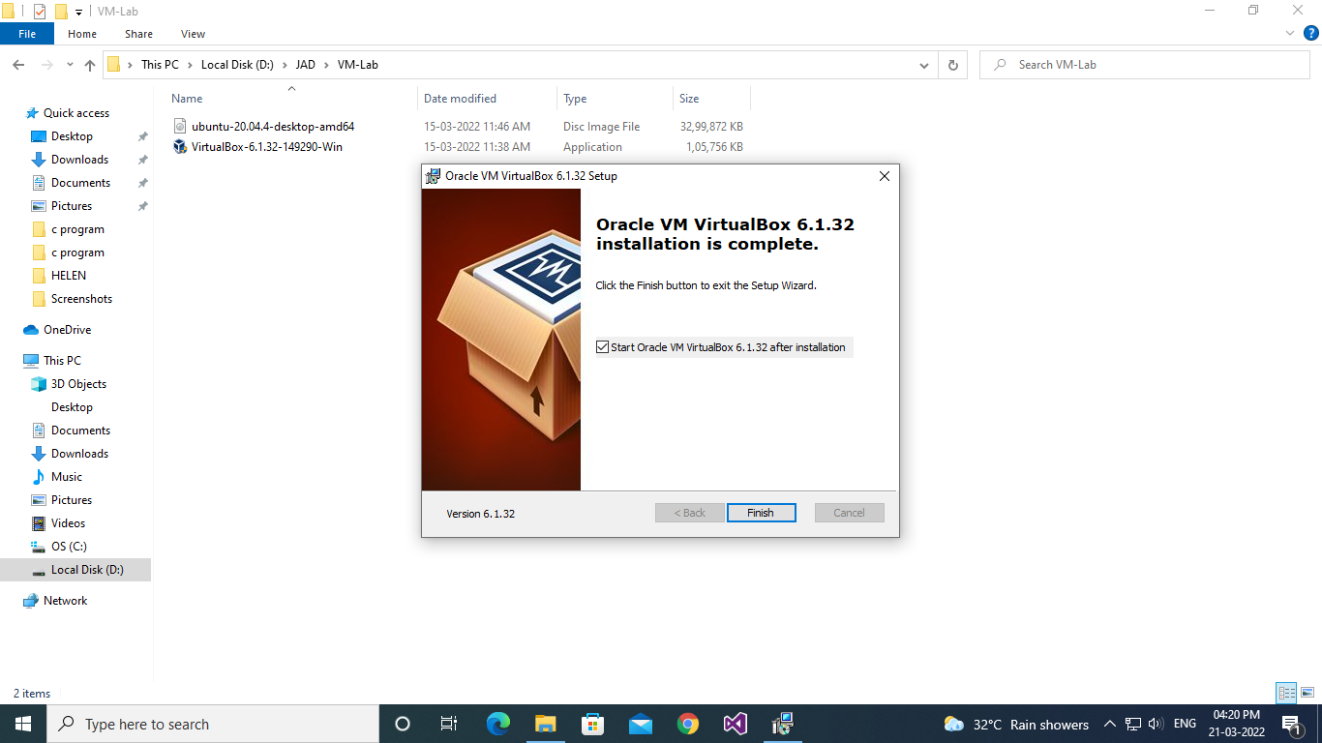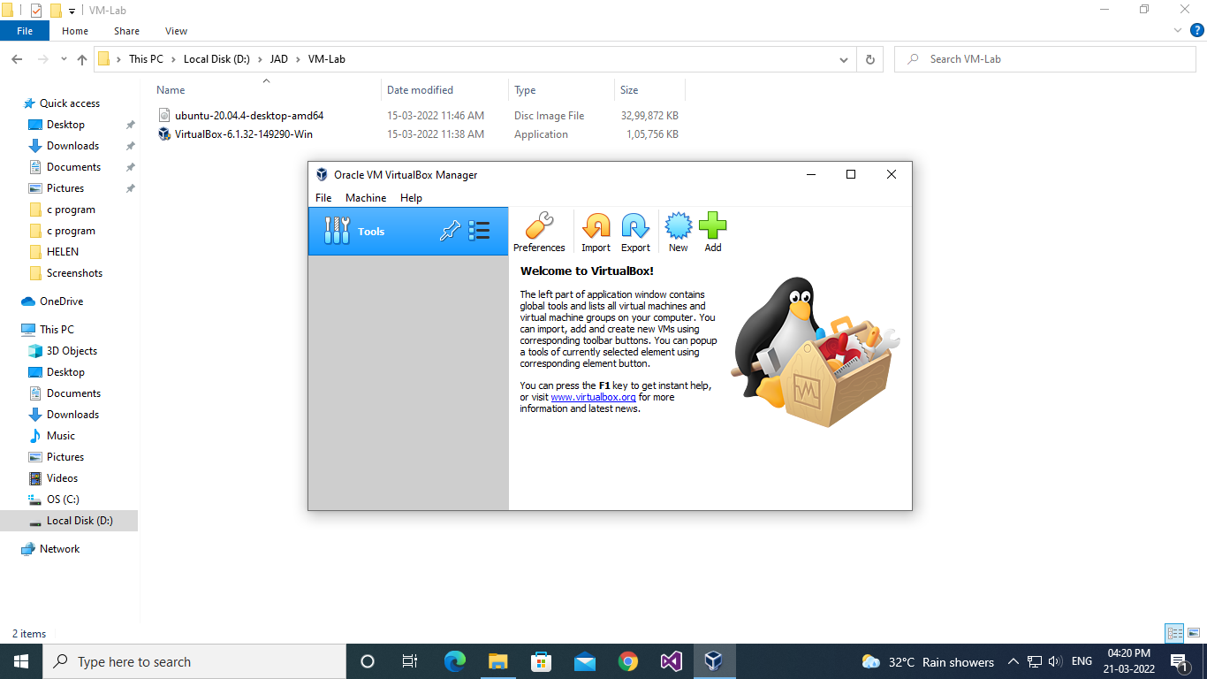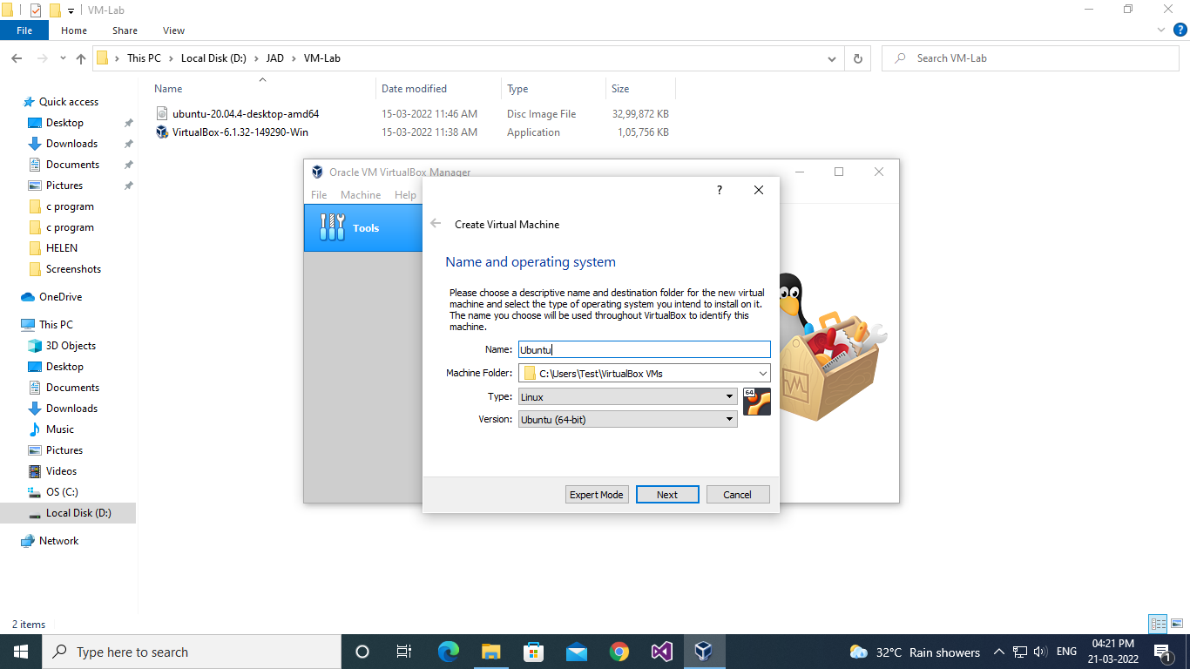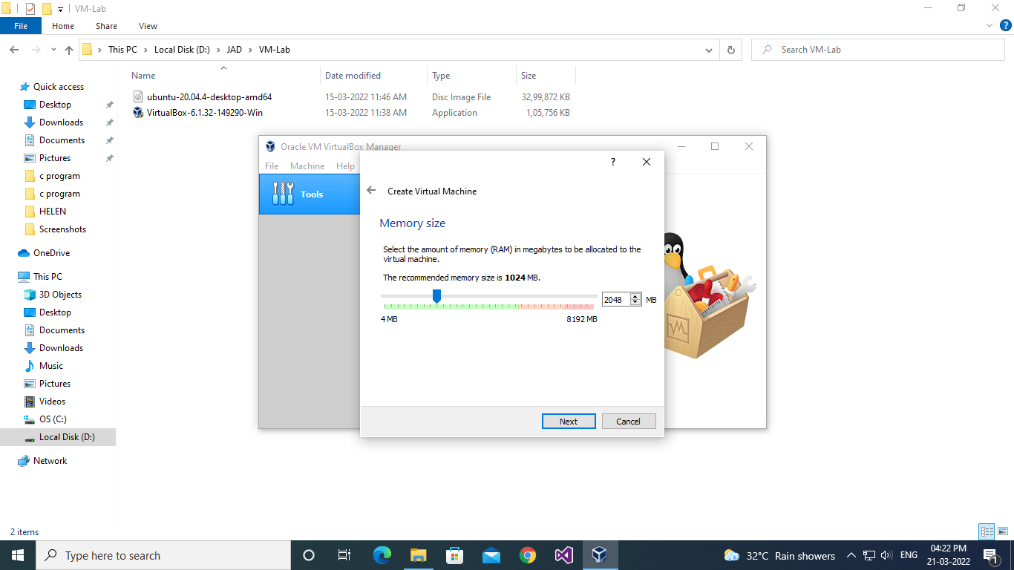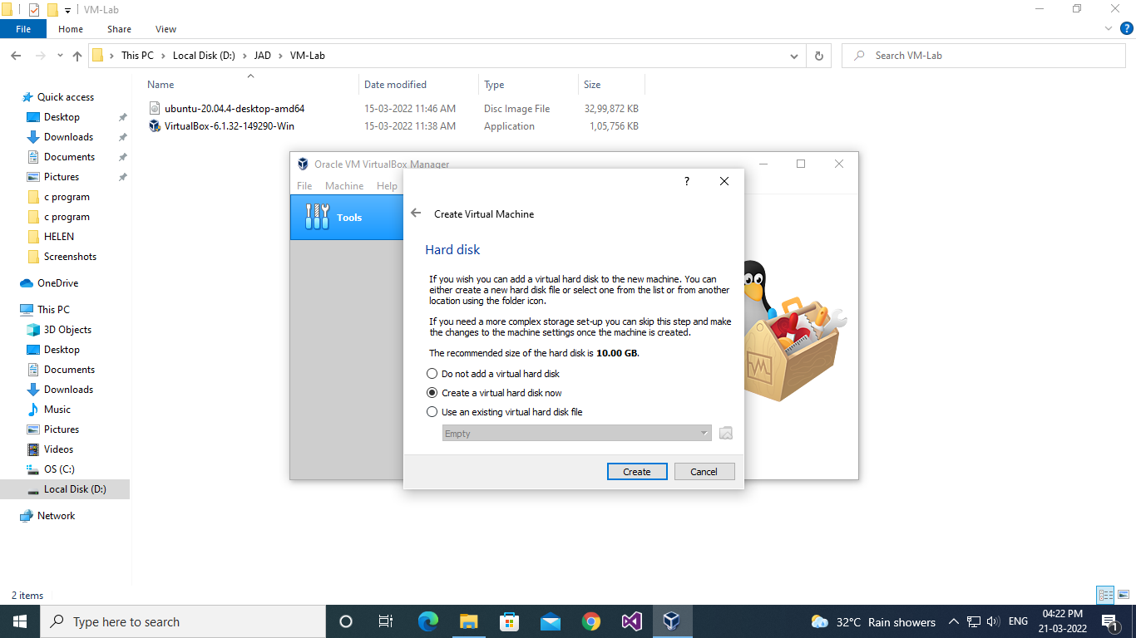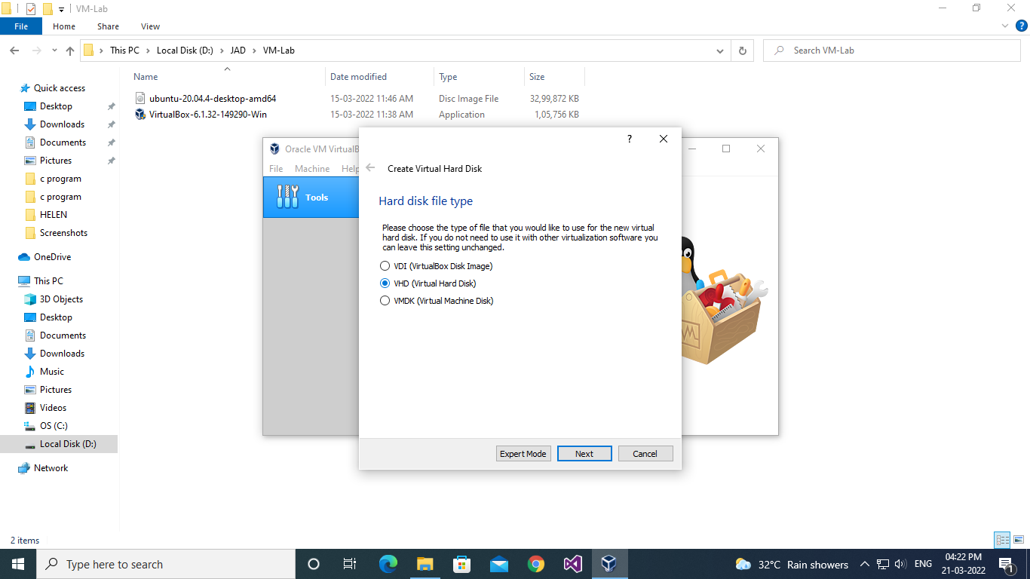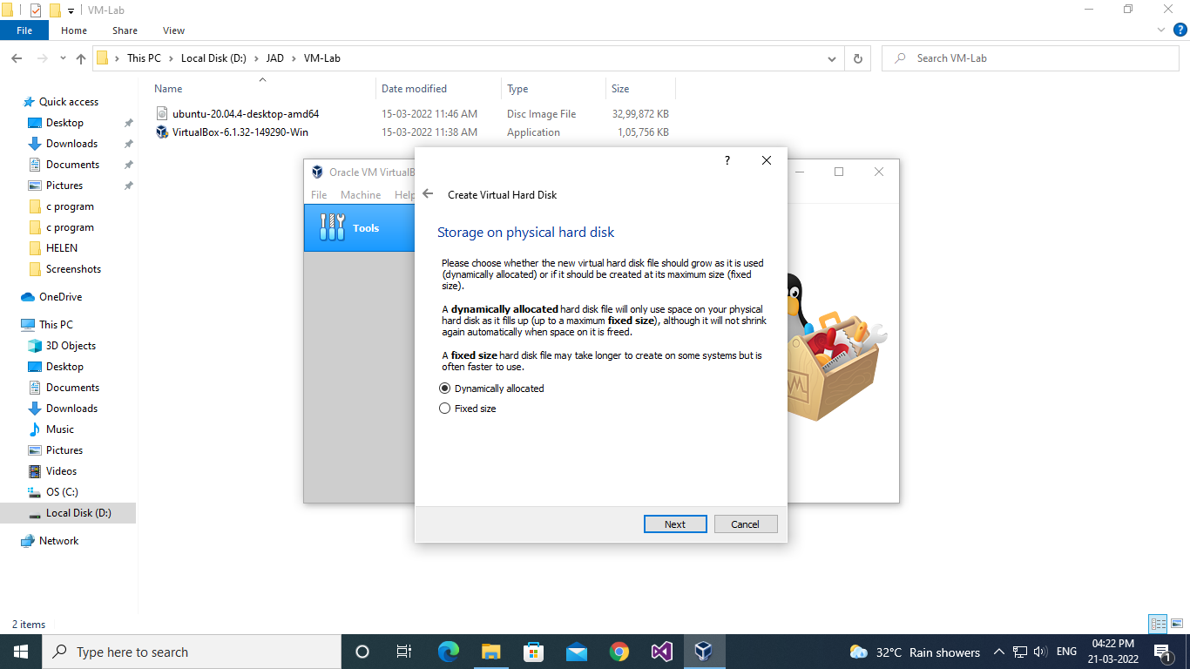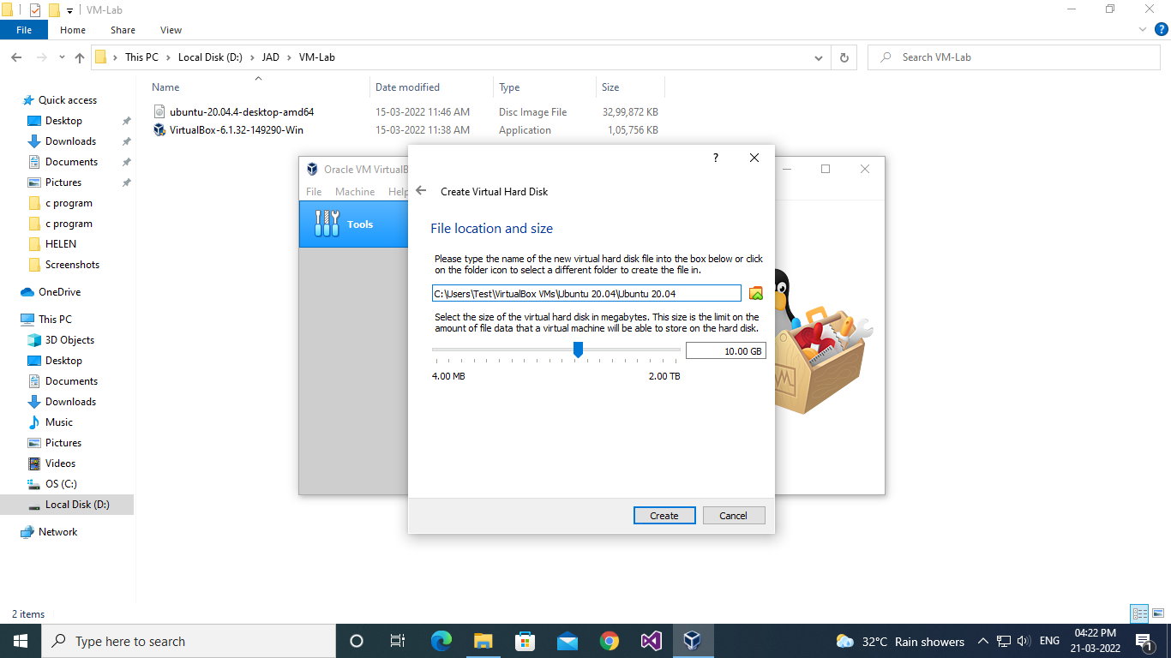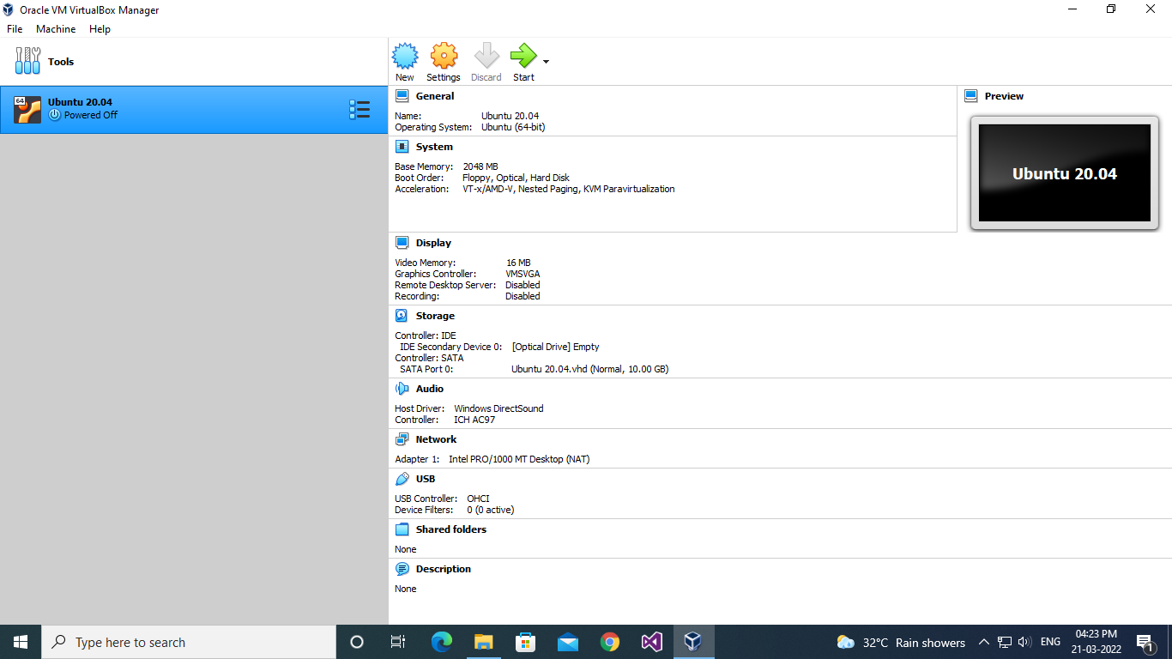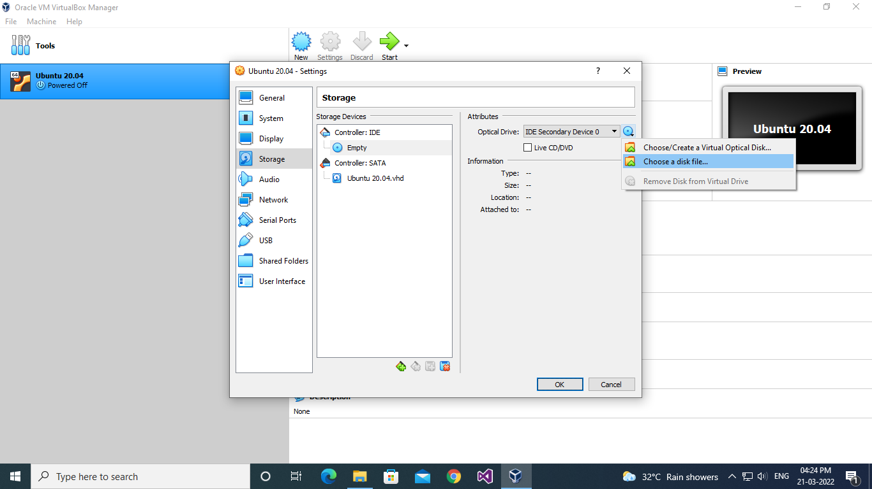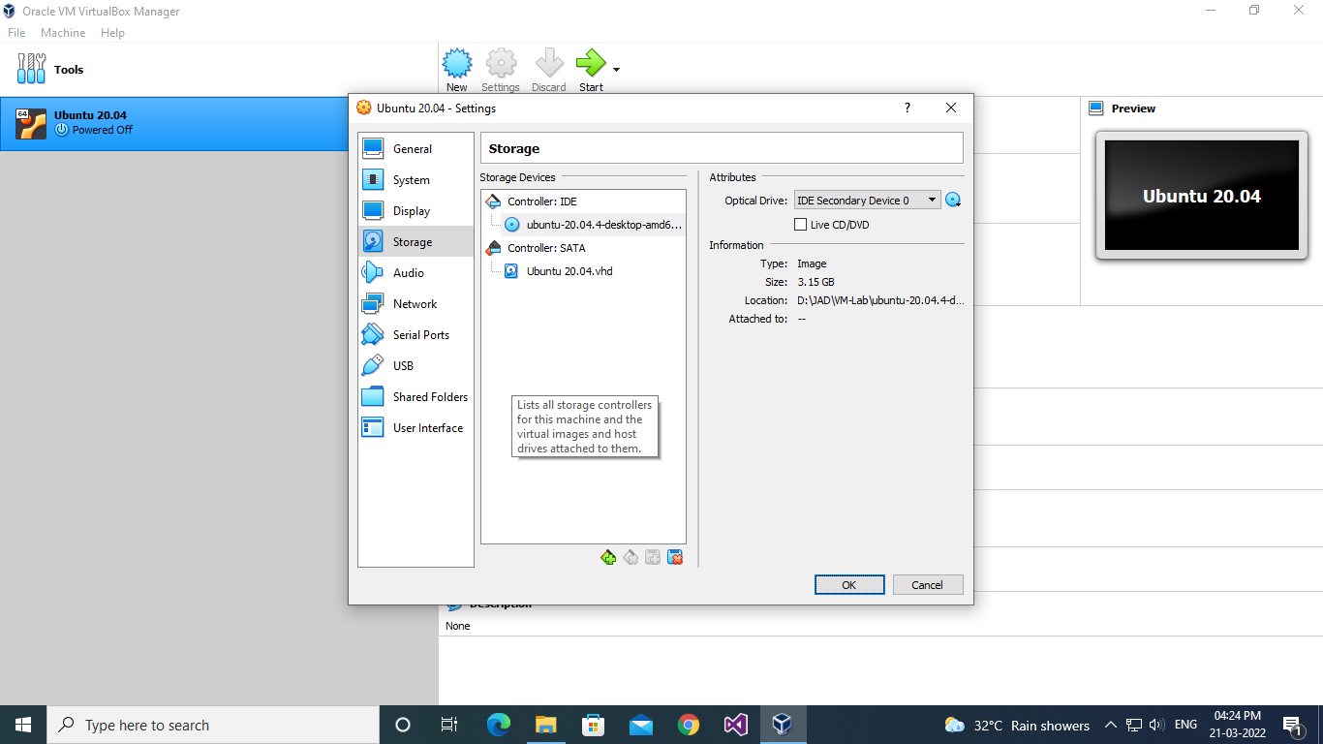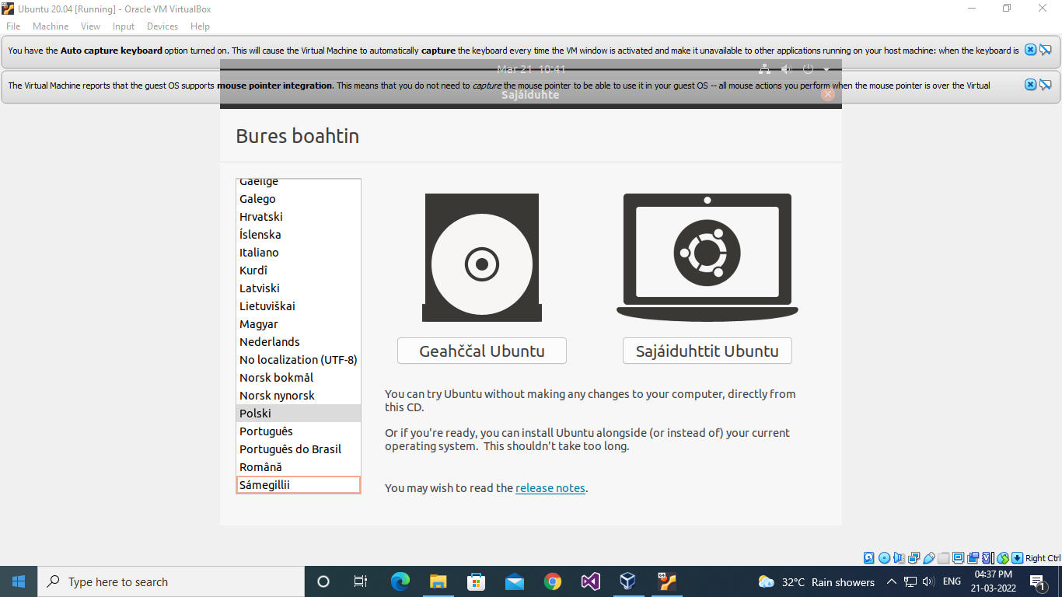

**Name: SHAMJAD MAZOOD NAZER**

**Roll No: 36**

**Batch: R-MCA B**

**Date: 21/03/2022**

**NETWORKING & SYSTEM ADMINISTRATION LAB**

**Experiment No.: 2**

**Aim**

.

**Procedure**

**Output Screenshot**

**Name: SHAMJAD MAZOOD NAZER**

**Roll No: 36**

**Batch: R-MCA B**

**Date: 21/03/2022**

**NETWORKING & SYSTEM ADMINISTRATION LAB**

**Experiment No.: 3**

**Aim**

.

**Procedure**

**Output Screenshot**